Publishing Bot Application on
Microsoft Azure.

Course Description
This module is for how to publish chatbot application on Microsoft Azure and other channels such as Skype.

Step 1 :Open portal.azure.com and login with Microsoft Account Credential.

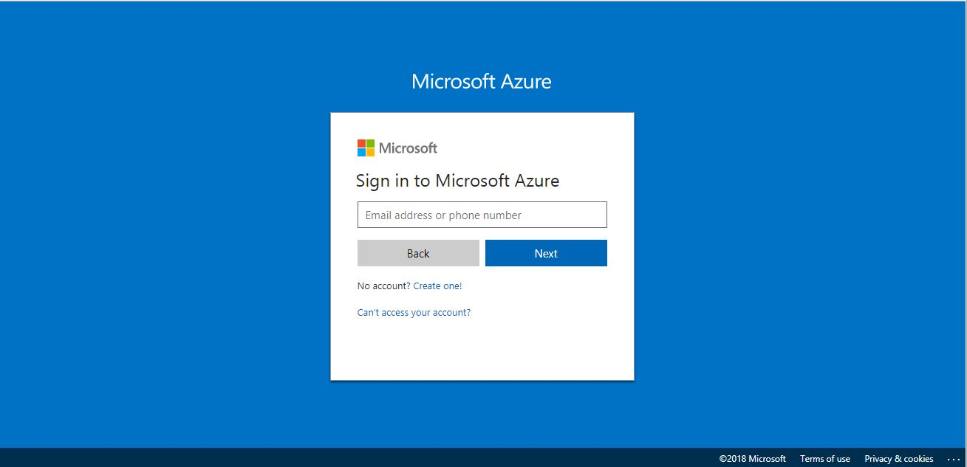

Step 2 : Click on “New” then select “AI+Cognitive Services” in “Azure Marketplace” section.

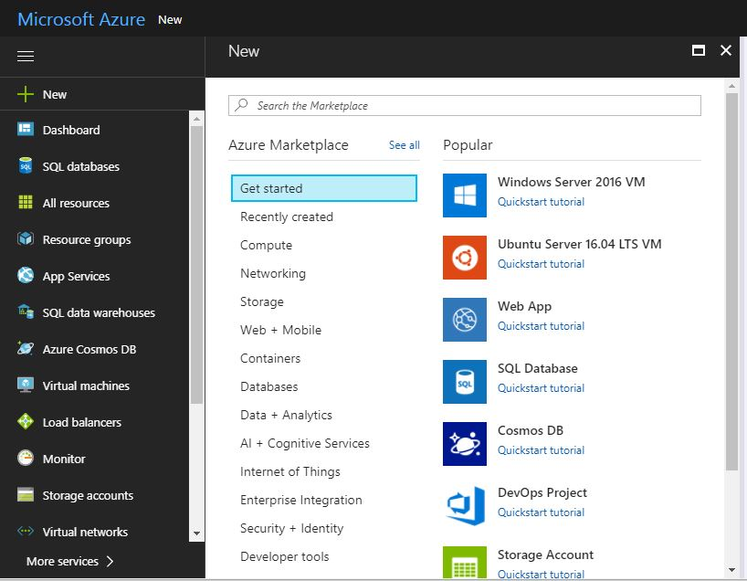
Step 3 : In “AI+Cognitive Services” click on “Web App Bot”.

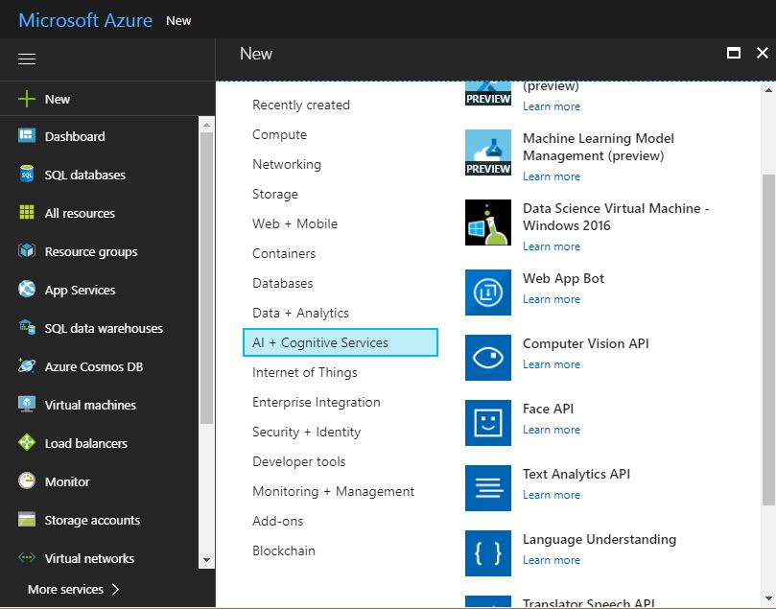

Step 4 : Enter all details in “Web App Bot” then click on “Create”.

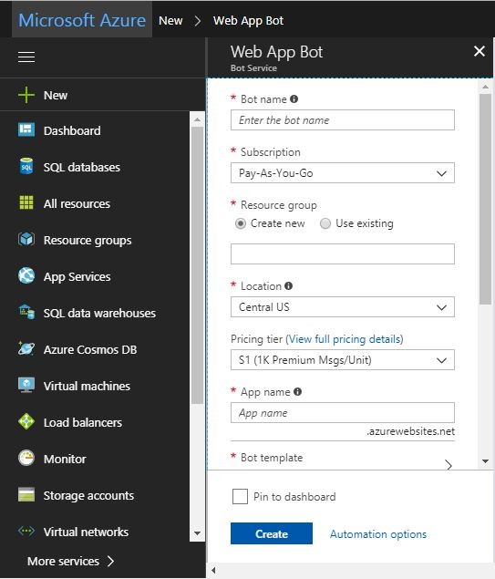

Step 5 : Go to the “BOT MANAGEMENT” section then click on “Build” option.

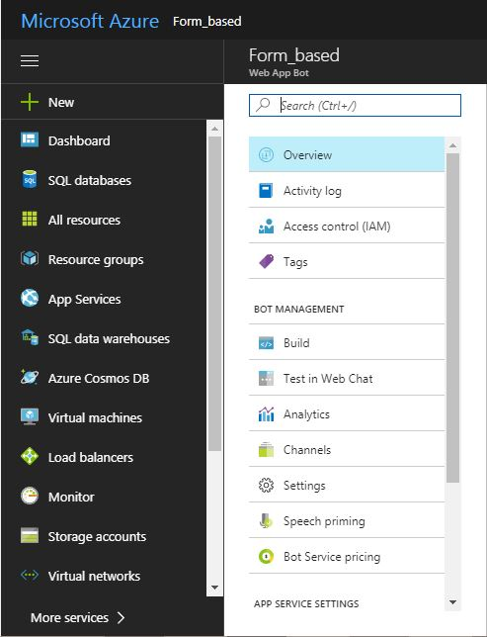

Step 6 : Inside “Build” go to “Online code editor” then click on “Open online code editor”.

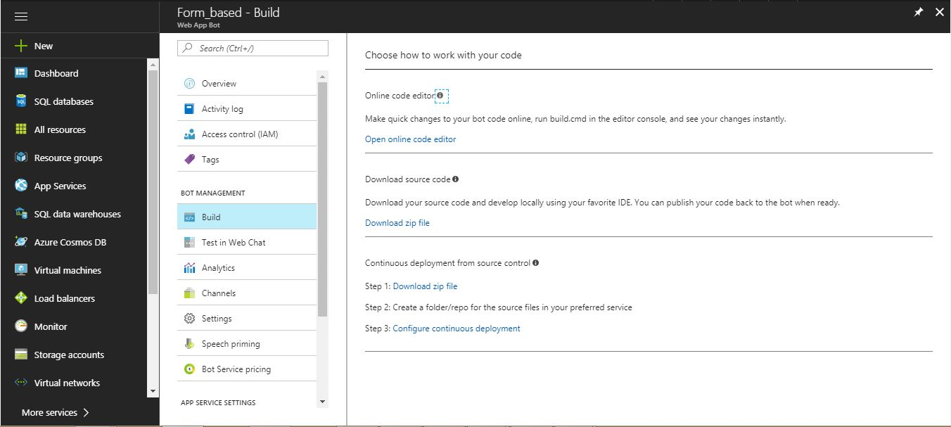

Step 7: In “App Service Editor” go to “app.js”.

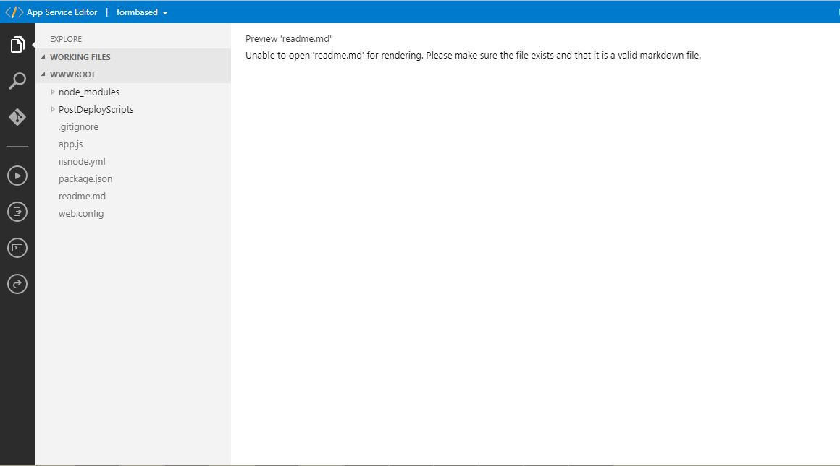

Step 8 : Delete default code which is in “app.js” file then copy code from your bot application and paste here in app.js.

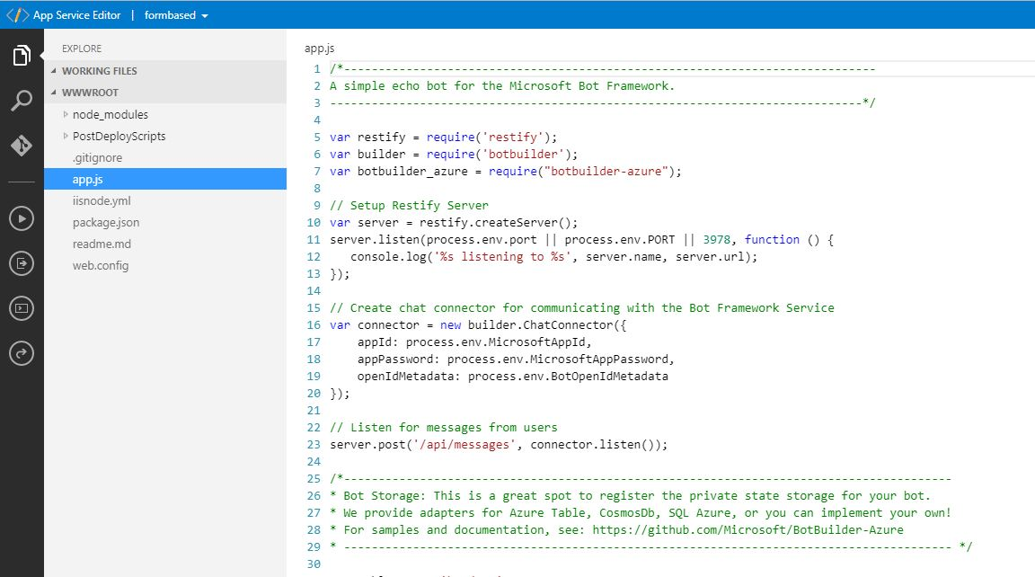

Step 9 : Go to console.(To open console click on this icon  on left Side of App Service Editor)and install following packages:
- Botbuilder
- Restify
- botbuilder_azure
Note: Install all packages which are necessary to run the bot.

- To install botbuilder package give following command on console:
npm install botbuilder

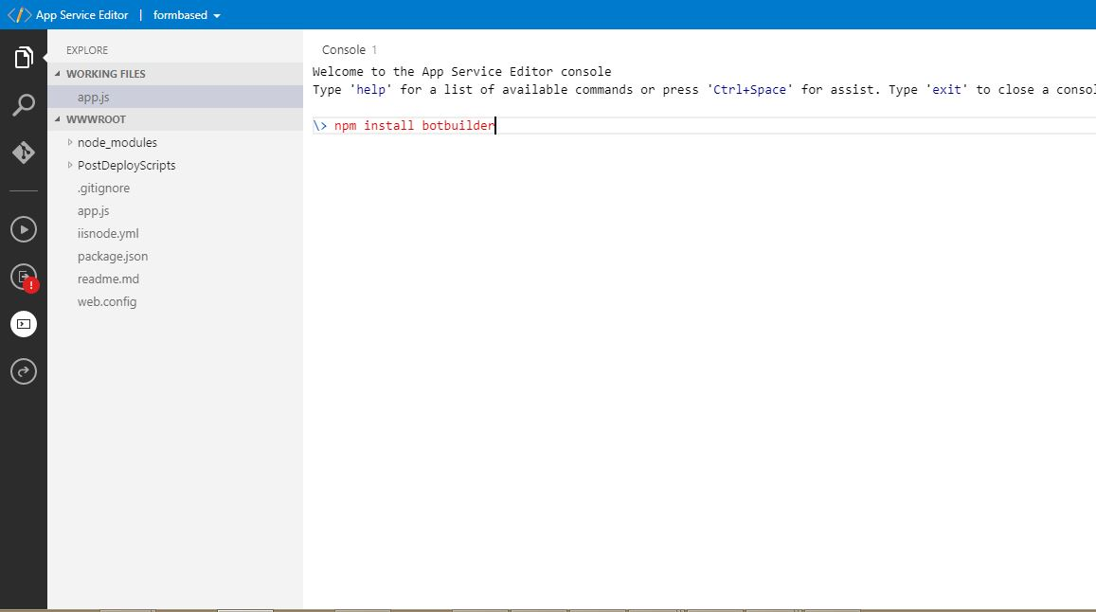

Step 10 : After installation of packages to test your code, click on this icon  on the left side of App Service Editor.
- If test is successful then new window will open in browser with the following message: {"code":"ResourceNotFound","message":"/ does not exist"}

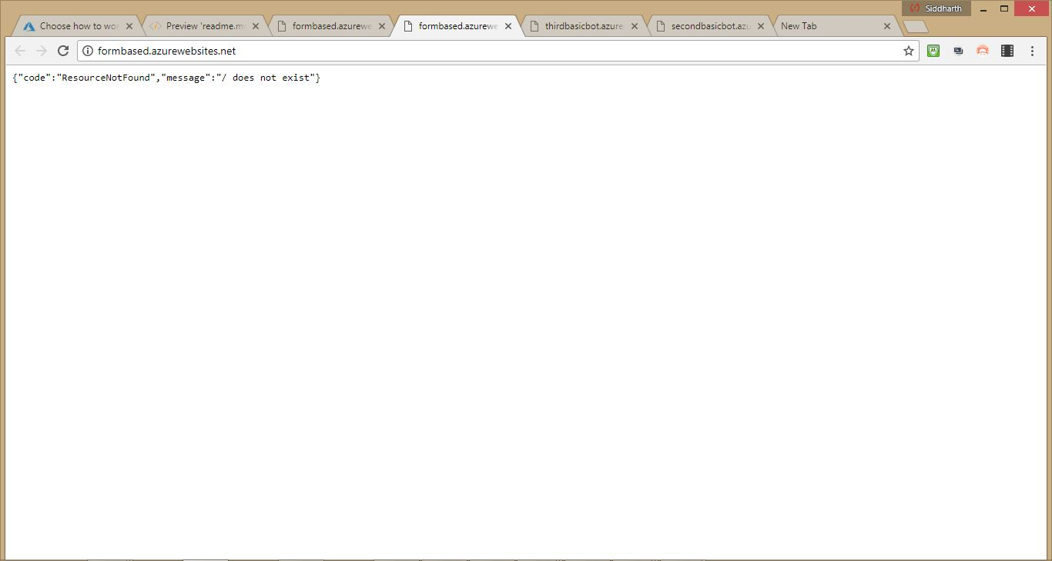
- If test is unsuccessful then new window will open in browser with the following error.

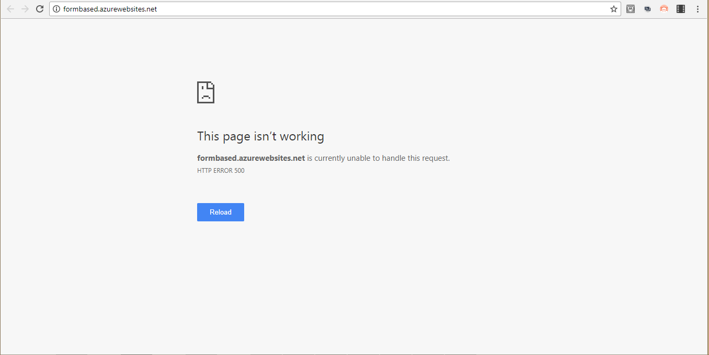

- If test is unsuccessful then click on this icon  on the left side of “App Service Editor”and check error in output.

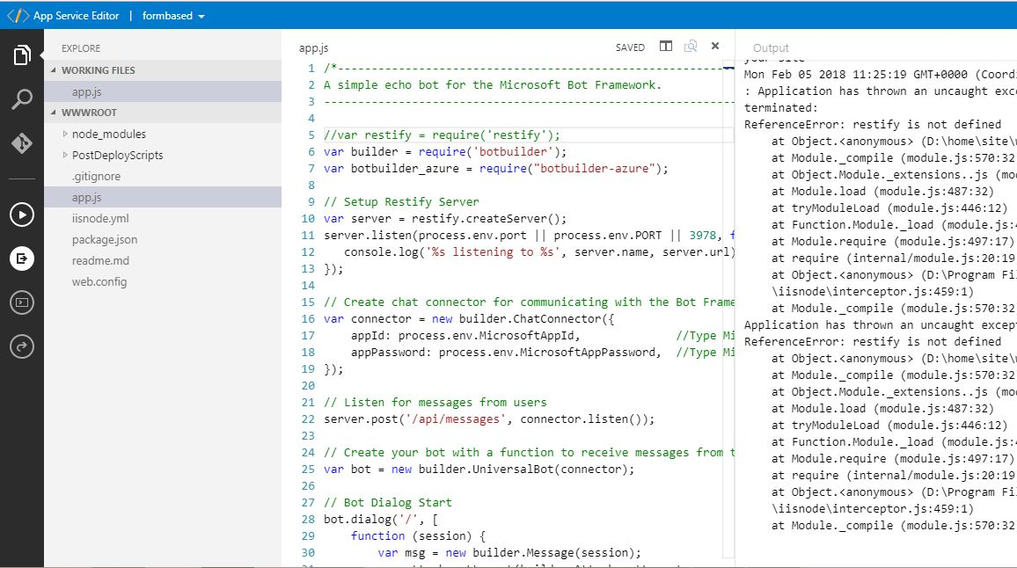

Step 11 : After testing your code, If your test is successful then go to Azure portal and open your application then click on “Test in Web Chat” option in “BOT MANAGEMENT” section to test working of your application .

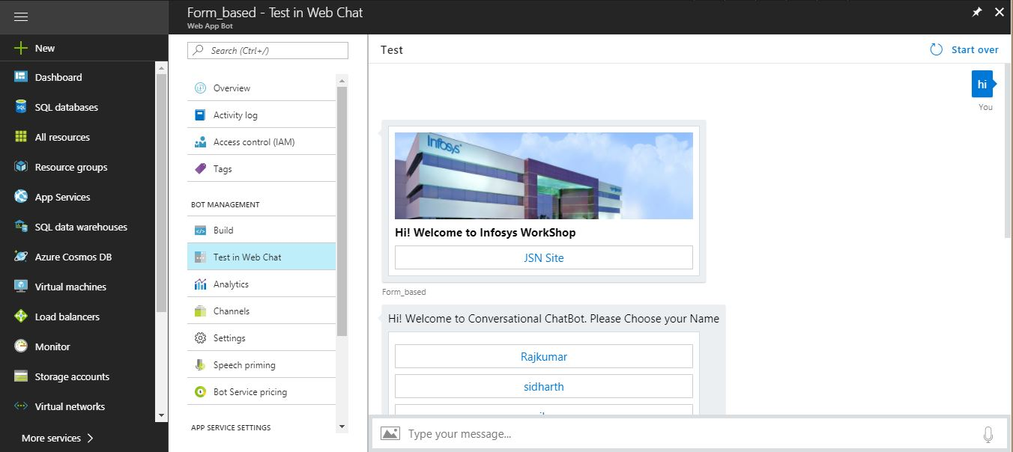

Step 12 : In BOT MANAGEMENT section go to Chaneels and select channels where you want publish your bot.
For example : To publish on Skype go to Add a featured channel option and click on skype.

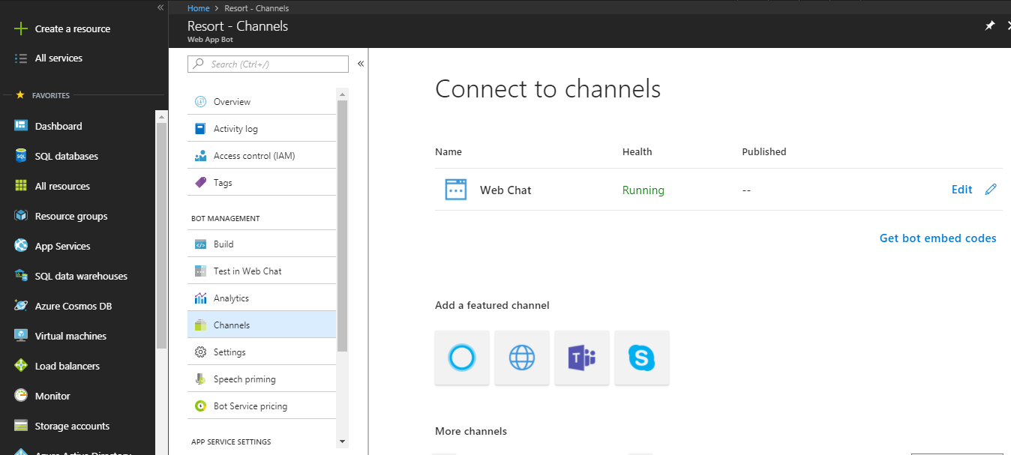

- Click on Get bot embed codes option and click on it.

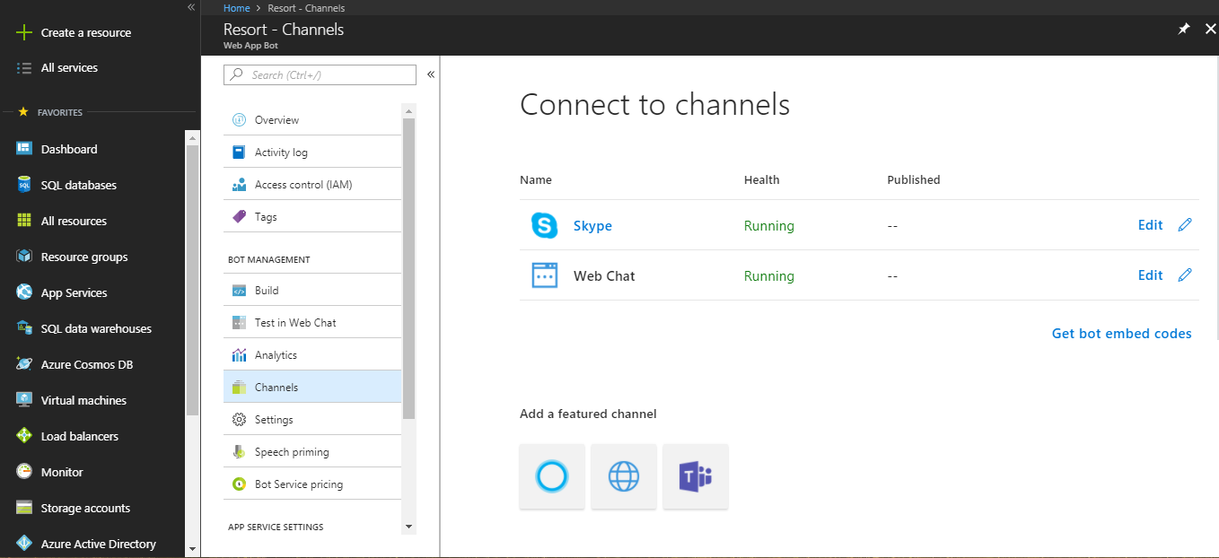

- Select Skype in Bot embed code and copy value of href and you can use this web Url to add the bot in your skype.

